**DOCUMENTATION OF PYTHON PROJECT**

**( STARBUCKS COFFEE)**

1. Open PYTHON PROJECT folder.
2. Open project.py file in PYTHON PROJECT folder.
3. Project is about billing system in Café’s eg. (STARBUCKS CAFÉ)
4. After opening the project.py file you will come across the gif photo you need to HOVER over the photo to proceed forward.

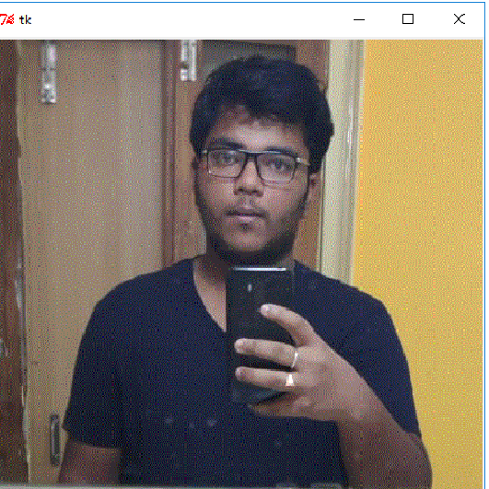

1. Then you will see personal details of this Python Project Developer. Close the window to start the billing of your Order.

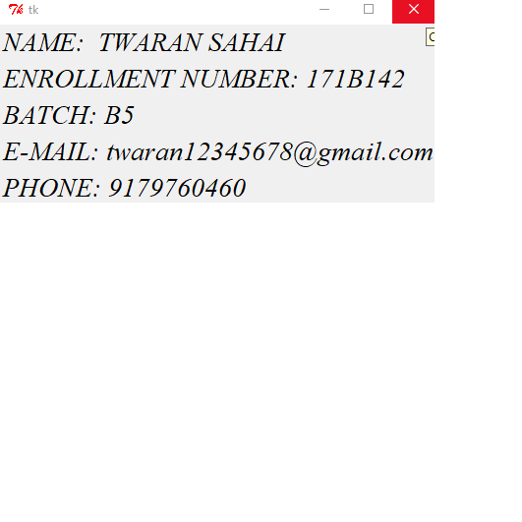

1. Gif photo of Starbucks Cafe will appear Hover over it.

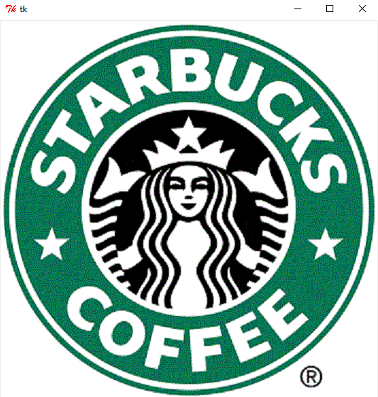

1. Next window appear is the main window of the project all the major process of project is done in this window only.

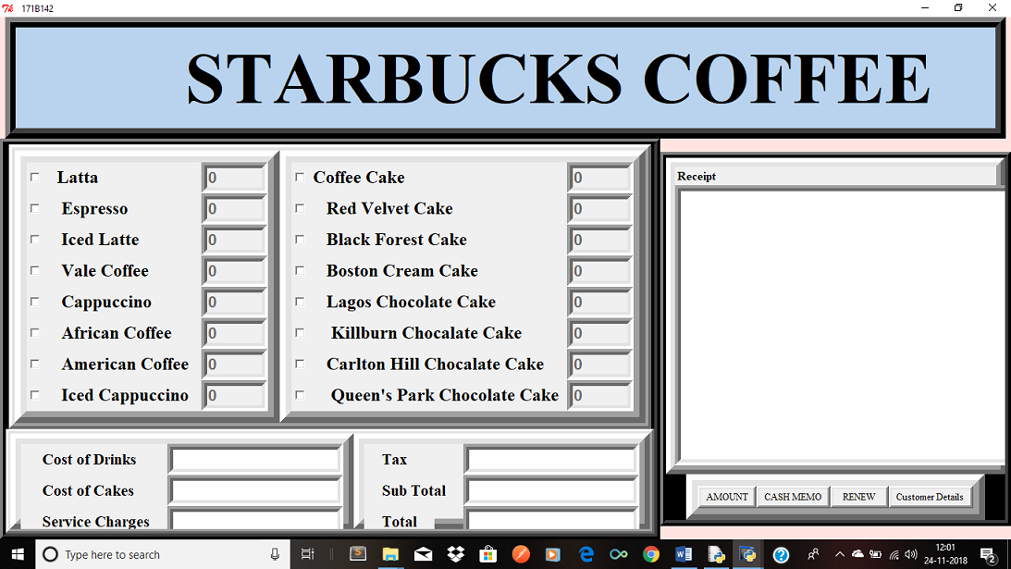

1. Click the checkbox of menu card (coffee or cake or both) items you want to Order. Enter the quantity of items in the respective boxes next to the checkbox ticked. Quantity should be entered by number keypad only. For eg. 1,10,100 etc.

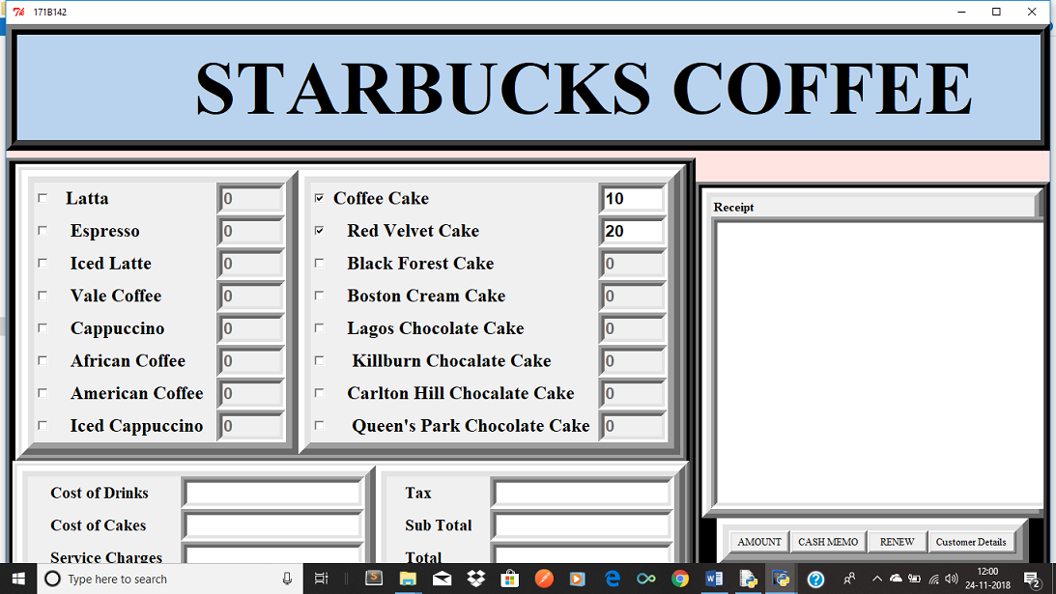

1. After selecting Your Order click on amount to see cost of your Order .

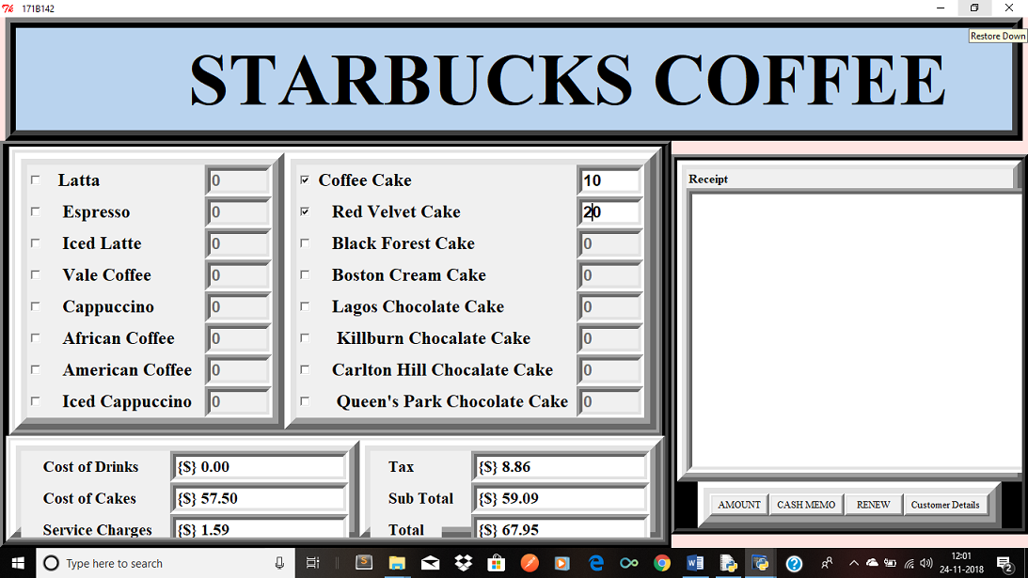

1. On the left corner of the window all the boxes which were empty till now after clicking AMOUNT will show you the

Cost of Drinks you ordered in ($ DOLLAR)

Cost of Cakes you ordered in ($ DOLLAR)

Service Tax in ($ DOLLAR)

Tax ($ DOLLAR)

Sub Total in($ DOLLAR)

Total in($ DOLLAR)

Total shows amount you have to pay for your ORDER (inclusive of all the taxes).



1. Click on Cash Memo to print receipt of your order .

Receipt will display unique BILL NUMBER on the top corner of RECEIPT TEXT BOX. All the drinks and cakes quantity you ordered will get displayed in the form of list in Receipt text box.

Quantities selected by the customer will get displayed with total and service tax at the end of it.

1. If after ordering and totalling of the items customer ordered, customer want to change his/her order Click Renew to give fresh start to your project . After clicking Renew you will land up again on STEP-07 again with fresh start. Now, you can order your changed order.
2. Click on Customer Detail button.
3. New window would pop up.
4. This window is DETAIL FORM of Customer for STARBUCKS GOLD CARD MEMBERSHIP.
5. The details asked in this form are

FULL NAME :

E-Mail ID :

Mobile No. :

(**NOTE-** Last Entry is for the customers who are already having STARBUCKS GOLD CARD MEMBERS and this unique ID will be provided by the employee of the Starbucks Café , On second visit of the customer personal details can be fetched by unique id of the customer.)

1. There are three button on the bottom of the pop up window (STARBUCKS GOLD CARD) that are-

Insert- As the name suggest, this button help to save customer details in STARBUCKS CAFÉ DATABASE .

Show- If the customer is already having membership card of the STARBUCKS CAFÉ ,then by entering (ENTER UNIQUE ID TO FETCH INFO) we can get his/her datails.

Show All- If Employee of Starbucks want to know details of customers entered so far he/she can click on SHOW ALL button.

1. Close the window by clicking on ( X ) on right left corner of the pop up window.
2. EXIT the project by clicking on (X) on the the project screen to close the Project page.

**Thank You!!!!**